Technijian (internal) — Veeam Backup for Microsoft 365
Monthly Backup Report — 2026-03
M365 tenant: Technijian365.onmicrosoft.com
Report generated: 2026-05-02 18:21
Executive Summary
297 M365 users in this tenant are protected by Veeam Backup for Microsoft 365. Total backup storage in use is 6.01 TB across 1 repository, with 1 active backup job. This report breaks down storage by Microsoft 365 service, lists per-user backup coverage, and projects how storage will grow over the next 12 months.
297  M365 Users | 42  Users w/ OneDrive backed up | 6.01 TB  Backup Storage Used | 1  Backup Jobs (Running)
Backup Posture
Job | Backup Type | Last Run | Status | Enabled | Next Run
TECH-O365 | EntireOrganization | 2026-05-02T07:35:02.5391539Z | Running | Yes | 2026-05-02T20:10:00Z
Backup repositories:
Repository | Used | Capacity | Free | Path
TECH-O365 | 6.01 TB | 7.00 TB | 1005.10 GB | C:\O365 Backups\bkp_TECH-365

Storage by M365 Module
Per-module bytes are estimated by attributing the tenant's total used backup storage in proportion to how often each service appeared in restore points over the last 90 days, weighted by industry-default ratios. For exact per-mailbox / per-site sizes, run the VB365 PowerShell module (Get-VBOEntityData).
Module | Estimated Storage | Share of Total | RP coverage (last 90d)
Exchange | 2.28 TB | 37.8% | 26 / 71
OneDrive | 2.82 TB | 47.0% | 71 / 71
SharePoint | 757.54 GB | 12.3% | 31 / 71
Teams | 179.20 GB | 2.9% | 22 / 71
Per-User Backup Coverage
297 users in the M365 directory. Mailbox coverage is set Yes for every user when the job is EntireOrganization (current setting). OneDrive coverage is determined by probing /users/{id}/onedrives.
Display Name | Email | Mailbox | OneDrive
GoDaddy Reseller | godaddy@Technijian.com | Yes | No
Defender Test | DefenderTest@technijian.com | Yes | Yes
Billing | billing_americanfundstars.com#EXT#@Technijian365.onmicrosoft.com | Yes | No
Greg Bisel | greg@Technijian.com | Yes | Yes
Brian Cox | BCox@Technijian.com | Yes | No
Devesh Bhattacharya | DBhattacharya@technijian.com | Yes | Yes
HealthMailbox-TE-HQ-CAS-01-006 | HealthMailbox7c0544c0ac754a21b0fa0c9073f5cd88@technijian.com | Yes | No
B2I -Security tools update | B2ISecuritytoolsupdate@Technijian365.onmicrosoft.com | Yes | No
Developers | devs@Technijian365.onmicrosoft.com | Yes | No
API Dev | apidev@Technijian365.onmicrosoft.com | Yes | No
HealthMailbox-TE-HQ-CAS-04-009 | HealthMailbox39f20793034545738809c7df6d5bf63a@technijian.com | Yes | No
Brett Varner | BVarner_orthoxpress.com#EXT#@Technijian365.onmicrosoft.com | Yes | No
HealthMailbox-TE-HQ-CAS-01-007 | HealthMailbox098f8ba02bf7473b9112caa337b6ac51@technijian.com | Yes | No
HealthMailbox-TE-HQ-MBX-03-MBDB01 | HealthMailbox1c84e0cf3a90442e9c87d30e3b159f45@technijian.com | Yes | No
HealthMailbox-TE-HQ-MBX-03-006 | HealthMailbox25e8e7e2e61f4b56ad0285f746653541@technijian.com | Yes | No
HealthMailbox-TE-HQ-MBX-03-010 | HealthMailbox2b397be0b9744b05a7890d5bfb44d3b9@technijian.com | Yes | No
Alex Alcantar | aalcantar@Technijian.com | Yes | Yes
Client Services | clientservices@technijian.com | Yes | Yes
HealthMailbox-TE-HQ-CAS-04-001 | HealthMailbox0646a66777c24ae4ac9b683070eba8ad@technijian.com | Yes | No
Hamid Yaghoubi | HamidYaghoubi@technijian.com | Yes | No
Accounting Sms | accounting_sms@technijian.com | Yes | No
HealthMailbox-TE-HQ-MBX-03-003 | HealthMailbox2406a2b72a55489dae70c60cf36bb8c7@technijian.com | Yes | No
Discovery Search Mailbox | DiscoverySearchMailbox{D919BA05-46A6-415f-80AD-7E09334BB852}@Technijian365.onmicrosoft.com | Yes | No
Client Portal Docs | cpdocs@Technijian.com | Yes | No
Defreg | Defreg@Technijian365.onmicrosoft.com | Yes | No
Chandra P. Jain | cpjain@Technijian.com | Yes | Yes
Gurdeep Kumar | gkumar@technijian.com | Yes | Yes
HealthMailbox-TE-HQ-CAS-01-009 | HealthMailbox2589e40cc64c4ee5a4d68d67faa781fa@technijian.com | Yes | No
AzureAD | AzureAD@Technijian365.onmicrosoft.com | Yes | No
Arun Oswal | aoswal@Technijian365.onmicrosoft.com | Yes | No
Deepak Bhardwaj | DBhardwaj@Technijian.com | Yes | Yes
HealthMailbox-TE-HQ-MBX-02-004 | HealthMailbox0194e594c661495cb1f697e8cabda56c@technijian.com | Yes | No
Chandni Jain | CJain@Technijian.com | Yes | Yes
ClientPortal1 | ClientPortal1@Technijian.com | Yes | No
Ali Ahmed | aahmed@technijian.com | Yes | No
HealthMailbox-TE-HQ-MBX-03-002 | HealthMailbox3835132c6fb94d1a8b174fbe9fc9a673@technijian.com | Yes | No
Bhushan Pagare | bpagare@Technijian.com | Yes | No
Daya Krishan Sharma | DKSharma@technijian.com | Yes | Yes
CP Monitoring | cpmonitoring@Technijian.com | Yes | No
HealthMailbox-TE-HQ-CAS-04-010 | HealthMailbox14ddf642993a4a04b358b425a4092ded@technijian.com | Yes | No
HealthMailbox-TE-HQ-MBX-02-005 | HealthMailbox9d59e71bf59743beabe8dbe8e0f5755d@technijian.com | Yes | No
Bernard Walker | bwalker@technijian.com | Yes | No
Client Portal | clientportal@technijian.com | Yes | No
Abhishek Kumar Poddar | apoddar@Technijian.com | Yes | No
archiver | archiver@technijian.com | Yes | No
ClientPortal2 | ClientPortal2@Technijian.com | Yes | No
Greg Bisel | greg.bisel@maxproleasing.com | Yes | No
Ajay Kumar | akumar@ecasys.com | Yes | No
Copy | Copy@technijian.com | Yes | No
ORX | admin_ORX365.onmicrosoft.com#EXT#@Technijian365.onmicrosoft.com | Yes | No
… and 247 additional users (full list in data.json).

Storage Trend & Projection
Projection method: industry default 4% MoM (will refine after 2+ monthly snapshots). Compound monthly growth rate used: 4.00%.
Horizon | Projected Storage | Δ vs today
Today (snapshot) | 6.01 TB | —
+3 months | 6.76 TB | +768.92 GB
+6 months | 7.61 TB | +1.60 TB
+9 months | 8.56 TB | +2.55 TB
+12 months | 9.63 TB | +3.61 TB
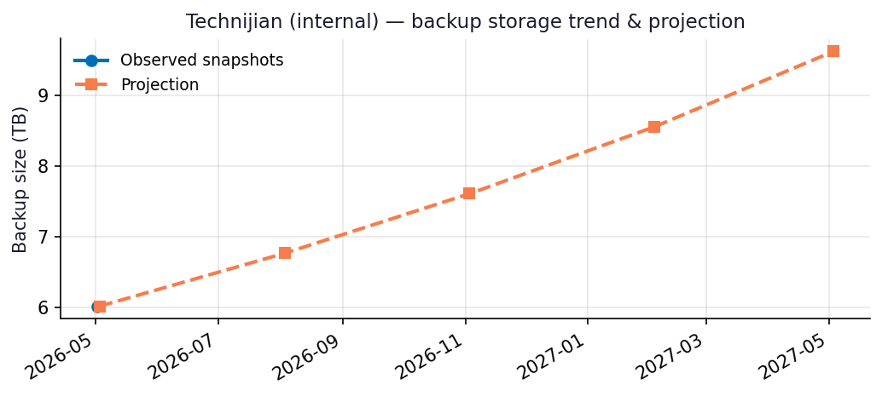
Recommendations
- Repository TECH-O365 is 86% full (1005.10 GB free of 7.00 TB capacity).
- Capacity flag: Repository will hit ~90% utilization within 3 months at the current trend — begin capacity planning now.
- Coverage gap: Only 42/297 users have OneDrive backups. Confirm whether the remainder are intentionally excluded (licensing, role-based scope) or need to be added.
- Run this report monthly. The projection accuracy improves with each snapshot — after 3 snapshots the linear-regression fit replaces the industry-default growth assumption.

Appendix: Methodology & Data Sources
Data sources
- Veeam Backup for Microsoft 365 REST API at https://10.7.9.227:4443/v8 (OAuth2 password grant; self-signed TLS).
- Endpoints used: /Organizations, /Organizations/{id}/usedRepositories, /Organizations/{id}/users, /Organizations/{id}/users/{uid}/onedrives, /BackupRepositories, /Jobs, /RestorePoints?backupTimeFrom=...
Per-module attribution caveat
REST does not expose per-mailbox or per-OneDrive backup byte counts on this build. Per-module estimates reweight the total used storage by the share of restore points (over the trailing 90 days) that included each service. Treat the numbers as informed estimates, not invoiced figures. For ground-truth per-user/per-team sizes use the VB365 PowerShell module Get-VBOEntityData.
Trend projection
- With <2 monthly snapshots: project at 4%/month compound.
- With ≥2 snapshots: linear regression on log(bytes) over time.

